**PASSPORT AUTOMATION SYSTEM**

**AIM:** To create an automated system to perform the Passport Process.

# PROBLEM STATEMENT:

Passport Automation System is used in the effective dispatch of passport to all of the applicants. This system adopts a comprehensive approach to minimize the manual work and schedule resources, time in a cogent manner. The core of the system is to get the online registration form (with details such as name, address etc.,) filled by the applicant whose testament is verified for its genuineness by the Passport Automation System with respect to the already existing information in the database. This forms the first and foremost step in the processing of passport application. After the first round of verification done by the system, the information is in turn forwarded to the regional administrator's (Ministry of External Affairs) office. The application is then processed manually based on the report given by the system, and any forfeiting identified can make the applicant liable to penalty as per the law. The system also provides the applicant the list of available dates for appointment to 'document verification' in the administrator's office, from which they can select one. The system forwards the necessary details to the police for its separate verification whose report is then presented to the administrator. The administrator will be provided with an option to display the current status of application to the applicant, which they can view in their online interface. After all the necessary criteria have been met, the original information is added to the database and the passport is sent to the applicant.

# SOFTWARE REQUIREMENT SPECIFICATION:

* 1. **INTRODUCTION**

**Passport Automation System** is an interface between the Applicant and the Authority responsible for the Issue of Passport. It aims at improving the efficiency in the Issue of Passport and reduces the complexities involved in it to the maximum possible extent.

# PURPOSE

If the entire process of 'Issue of Passport' is done in a manual manner then it would takes several months for the passport to reach the applicant. Considering the fact that the number of applicants for passport is increasing every year, an Automated System becomes essential to meet the demand. So this system uses several programming and database techniques to elucidate the work involved in this process. As this is a matter of National Security, the system has been carefully verified and validated in order to satisfy it.

# SCOPE

* + - The System provides an online interface to the user where they can fill in their personal details and submit the necessary documents (may be by scanning).
    - The authority concerned with the issue of passport can use this system to reduce his workload and process the application in a speedy manner.
    - Provide a communication platform between the applicant and the administrator.
    - Transfer of data between the Passport Issuing Authority and the Local Police for verification of applicant's information.
    - Users/Applicants will come to know their status of application and the date in which they must subject themselves for manual document verification.

# DEFINITIONS, ACRONYMS AND THE ABBREVIATIONS

* **Administrator**

Refers to the super user who is the Central Authority with the privilege to manage the entire system. It can be any higher official in the Regional Passport Office of Ministry of External Affairs.

# Applicant

One who wishes to obtain the Passport.

# PAS

Refers to this Passport Automation System.

# HTML

Markup Language used for creating web pages.

# HTTP

Hyper Text Transfer Protocol.

# TCP/IP

Transmission Control Protocol/Internet Protocol is the communication protocol used to connect hosts on the Internet.

# TECHNOLOGIES TO BE USED

* HTML

# TOOLS TO BE USED

* Eclipse IDE (Integrated Development Environment)
* Rational Rose tool (for developing UML Patterns)

# OVERVIEW

SRS includes two sections overall description and specific requirements

**Overall Description** will describe major role of the system components and

inter-connections.

**Specific Requirements** will describe roles & functions of the actors.

# OVERALL DESCRIPTION

* 1. **PRODUCT PERSPECTIVE**

The PAS acts as an interface between the 'applicant' and the 'administrator'. This system tries to make the interface as simple as possible and at the same time not risking the security of data stored in. This minimizes the time duration in which the user receives the passport.

# SYSTEM FUNCTIONS

* Secure Registration of information by the Applicants.
* Schedule the applicants an appointment for manual verification of original documents.
* Panel for Passport Application Status Display by the Administrator.
* SMS and Mail updates to the applicants by the administrator.
* Administrator can generate reports from the information and is the only authorized personnel to add the eligible application information to the database.

# USER CHARACTERISTICS

* **Applicant**

These are the person who desires to obtain the passport and submit the information to the database.

# Administrator

He has the certain privileges to add the passport status and to approve the issue of passport. He may contain a group of persons under him to verify the documents and give suggestion whether or not to approve the dispatch of passport.

# Police

He is the person who upon receiving intimation from the PAS, perform a personal verification of the applicant and see if he has any criminal case against him before or at present. He has been vetoed with the power to decline an application by suggesting it to the Administrator if he finds any discrepancy with the applicant. He communicates via this PAS.

# CONSTRAINTS

* The applicants require a computer to submit their information.
* Although the security is given high importance, there is always a chance of intrusion in the web world which requires constant monitoring.
* The user has to be careful while submitting the information. Much care is required.

# ASSUMPTIONS AND DEPENDENCIES

* The Applicants and Administrator must have basic knowledge of computers and English Language.
* The applicants may be required to scan the documents and send.

# (I) USECASE DIAGRAM:

The Passport Automation system use cases are:

1. Login
2. Registration
3. Verification
4. Check status
5. Enquiry
6. Dispatch Passport

# ACTORS INVOLVED:

1. Applicant
2. Passport Officer
3. Police

# USE-CASE NAME: LOGIN

The applicant login to the system to obtain a passport

# USE-CASE NAME: REGISTRATION

The Applicant enters his name and details for applying a Passport .The applicant initially give his/ her details for registration.

# USE-CASE NAME: VERIFICATION

The system verifies the applicant mandatory information given by him/her.

# USE-CASE NAME: CHECK STATUS

The Applicant tries to check the status in which category applied. The system displays the message to the applicant.

# USE-CASE NAME: ENQUIRY

The police receive intimation from the PAS, perform a personal verification of the applicant and see if he has any criminal case against him before or at present. He has been vetoed with the power to decline an application by suggesting it to the Administrator if he finds any discrepancy with the applicant. He communicates via this PAS.

# USE-CASE NAME: DISPATCH PASSPORT

The administrator check or process the application which are submitted by applicant .Process the application means the data which are given by the applicant is processed to create a passport for the applicant and finally dispatches the passport to the applicant

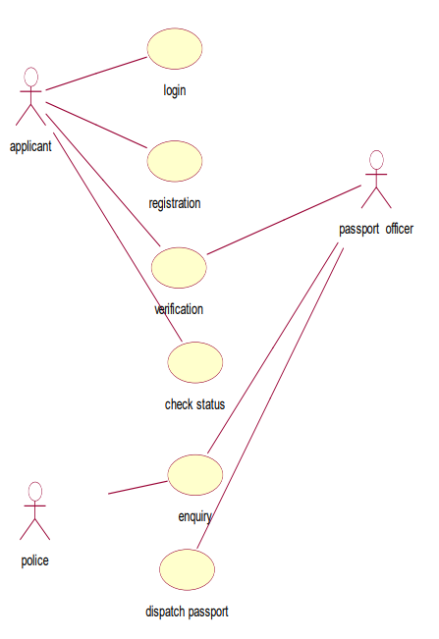

**FIG:USECASE DIAGRAM FOR PASSPORT AUTOMATION SYSTEM**

**(II)** **ACTIVITY DIAGRAM:**

The activity diagram represents the series of activities that are occurring between the objects. Following is activity diagram which represents the Software personnel management system process .

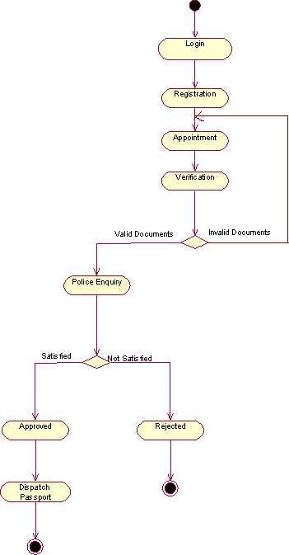

**FIG:ACTIVITY DIAGRAM FOR PASSPORT AUTOMATION SYSTEM**

# (III)CLASS DIAGRAM:

The class diagram is referred as object modeling in the static analysis diagram. The main task of object modeling is to graphically show what each object will do in the problem domain. The problem domain describes the structure and the relationships among objects.

The Passport Automation system class diagram consists of five classes

* 1. Login class
  2. Appointment class
  3. Registration class
  4. Authority class
  5. Verification class

# LOGIN CLASS:

It consists of two attributes and two operations. The attributes are user name, and password. The operations of this class are creating login ( ), sign in ( ).

# APPOINMENT CLASS:

The attributes of this class are appointment id, applicant id, date, time, and description. The operation of this class are get appointment ( ), get appointment status ( ), Modify ( ), cancel ( ).

# REGISTRATION CLASS:

The attributes are applicant id, name, dob, gender, birthplace, father name, addr1, addr2, district, state, country, pin code, mobile, email id, qualification. The operation are add ( ), modify ( ), view ( ).

# AUTHORITY CLASS:

The attributes of this class are officered, name, designation, and password. The operations are search ( ).

# VERIFICATION CLASS:

The attributes of this class are verification id, appointment id, applicant id, officer id, status id, description. The operation are verify ( ).

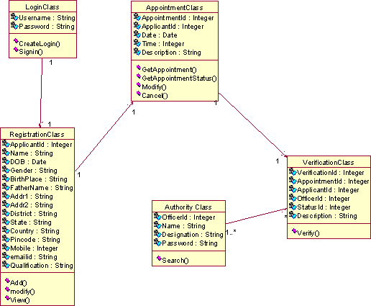

**CLASS DIAGRAM FOR PASSPORT AUTOMATION SYSTEM**

# (IV) INTERACTION DIAGRAM:

* A sequence diagram represents the sequence and interactions of a given USE-CASE or scenario. Sequence diagrams can capture most of the information about the system.
* Most object to object interactions and operations are considered events and events include signals, inputs, decisions, interrupts, transitions and actions to or from users or external devices.
* An event also is considered to be any action by an object that sends information.
* The event line represents a message sent from one object to another, in which the “form” object is requesting an operation be performed by the “to” object. The “to” object performs the operation using a method that the class contains.
* It is also represented by the order in which things occur and how the objects in the system send message to one another.
* The sequence diagram for each USE-CASE that exists when a user administrator, check status and new registration about passport automation system are given.

**SEQUENCE DIAGRAM FOR LOGIN AND VERIFICATION**



: applicant

UI

LoginClass

RegistrationClass

AppointmentClass

Database



Create Login

Enter Username/Pwd

Check username/Pwd

save username/pwd

Signin

get username/pwd

Check username/Pwd

show Registration Form

Enter applicant information

check applicant information

save applicant information

get date and time

save date and time

shows applicant ID, Date & time

Database

UI

AppointmentClass

RegistrationClass

LoginClass

**FIG:SEQUENCE DIAGRAM FOR LOGIN AND VERIFICATION**

12: Check username/Pwd

5: Check username/Pwd

1: Create Login

3: Enter Username/Pwd

9: Signin 4:

|  |  |  |  |
| --- | --- | --- | --- |
| UI |  | LoginCla  ss | |
|  |
| 10: get username/pwd  6: sav  7:  11: | | | e use |
|  | | Databas  e | |

14: Enter applicant information

: applicant

2:

8:



13: show Registration Form

24: shows applicant ID, Date & time

23:

rname/pwd

16: check applicant information

15:

17: save applicant information

19: get date and time

Registratio

nClass

18:

20: save date and time

21:

22:

Appointme

ntClass

**COLLABORATION DIAGRAM FOR LOGIN AND VERIFICATION**

* The diagrams show the process done by the Passport Authority to the Passport Automation system. The applicant has to enter his details.
* The details entered are verified by the Passport Authority and the applicant is approved if the details match then the passport is dispatch, otherwise an appropriate error message is displayed.

# STATE CHART DIAGRAM:

* Every object undergoes through some state and on receiving some event the state gets changed. This transition of the state can be represented by the state transition diagram.

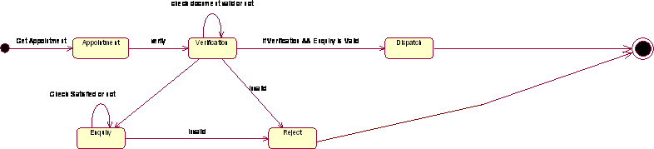

**STATE CHART DIAGRAM FOR PASSPORT AUTOMATION SYSTEM**

# DEPLOYMENT DIAGRAM AND COMPONENT DIAGRAM

Deployment diagrams are used to visualize the topology of the physical components of a system where the software components are deployed.

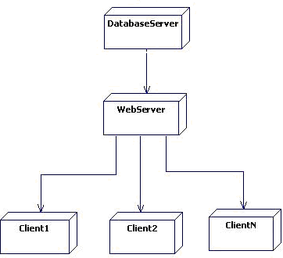

**DEPLOYMENT DIAGRAM FOR PASSPORT AUTOMATION SYSTEM**

# COMPONENT DIAGRAM

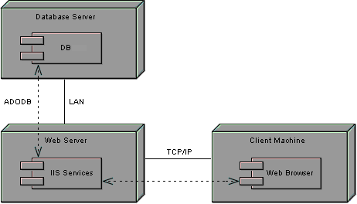Component diagrams are used to visualize the organization and relationships among components in a system.

**COMPONENT DIAGRAM FOR PASSPORT AUTOMATION SYSTEM**